ASR 6978

KPI - Daily Split Request Report

Date: 2018.03.13

Datasource : SCH_OFI_SPLIT_REQUEST

Report format:

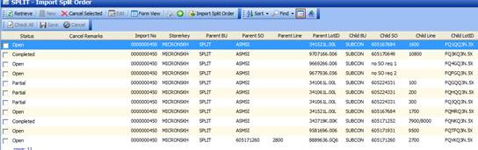

**Request 3: To have the below for split record.**

Weekday:

-          Meet TAT <= 2:30pm     => PF: this timing is referring to scan completed time before 2:30pm? For order imported that day, should complete before 2:30PM

-          Not Meet TAT > 2:30pm

Weekend (Only Sat)

-          Meet TAT <= 12pm         => PF: this timing is referring to scan completed time before 12PM ? For order imported that weekend, should complete before 12PM

-          Not Meet TAT > 12pm

Replied: Yes end at scan completed timing before 02:30pm for those order imported before 02:30pm, same day shipment.

System Specification:

Report title

KPI - Daily Split Request Report

Summary reference to “Daily SK Outbound SO Summary report”

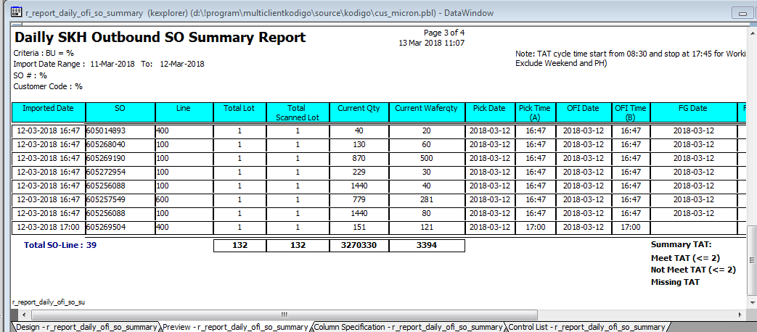

Update

2018-04-05 from Akash

**From:** Baghel, Akash   
**Sent:** Thursday, 05 April, 2018 7:15 PM  
**To:** Chan, Pei-Fong  
**Cc:** Low, Dennis; Caliwliw, Ferdinand  
**Subject:** RE: CR/WMS/MICRONOFI - ASR 6979 Daily Split Record status Report

Hi Pei Fong

I have done this development and testing.

Please find the attachment data window and objects.

1.       When user launch the object screen will this:

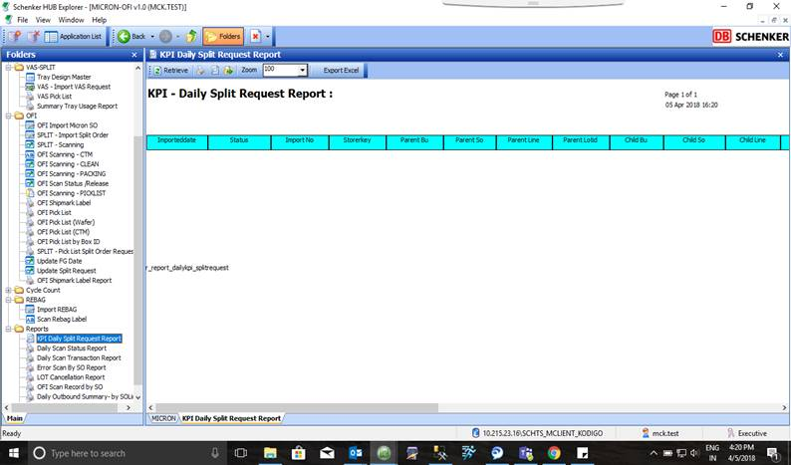

2.       When user enter the date range:

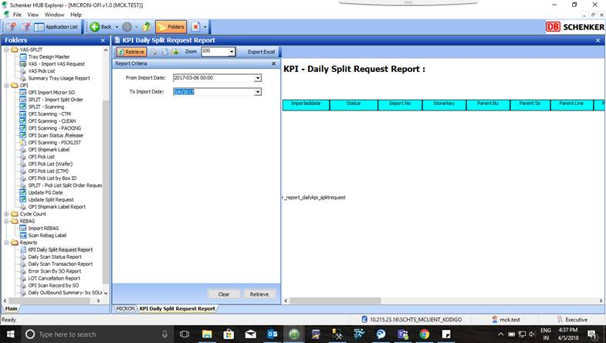

3.       When user click the Retrieve Button then data Showing:

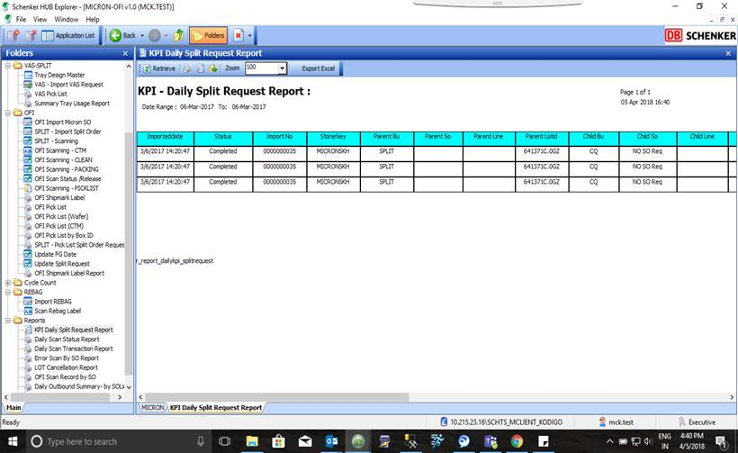

4.       User can see the TAT Status also:

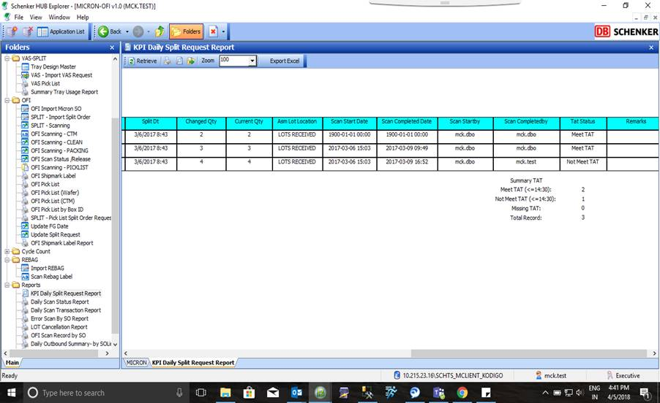

Please  check and revert